**SHLOK ANAND**

**23070521142**

**CN: PRACTIAL NO.1**

**AIM: STUDY OF BASIC ELEMENTS OF COMPUTERS NETWORKING WITH DETAILS OF NETWORKING DEVICES.**

* **Hub**: A simple networking device that broadcasts data to all connected devices without filtering.
* **Switch**: A device that forwards data only to the intended device using MAC addresses.
* **Router**: Connects multiple networks and directs data packets based on IP addresses.
* **Repeater**: Amplifies and retransmits network signals to extend coverage.
* **Bridge**: Connects and filters traffic between two different LAN segments.
* **Modem**: Converts digital data into analog signals (and vice versa) for internet access.

**Topology**: The arrangement or layout of devices and connections in a computer network.

* **Bus Topology**: All devices share a single central communication line (backbone).
* **Star Topology**: All devices connect to a central hub or switch.
* **Ring Topology**: Devices are connected in a circular path where data passes in one direction.
* **Mesh Topology**: Every device is connected to every other device for maximum reliability.

**TYPES OF CABLES**

* **Twisted Pair Cable**: Consists of pairs of insulated copper wires twisted together, commonly used in LANs.
* **Coaxial Cable**: Has a central conductor, insulating layer, and shield, used for cable TV and networking.
* **Fibre Optic Cable**: Uses light signals through glass/plastic fibers for high-speed, long-distance communication.

**NETWORK TROUBLESHOOTING COMMANDS:**

**1.PING**

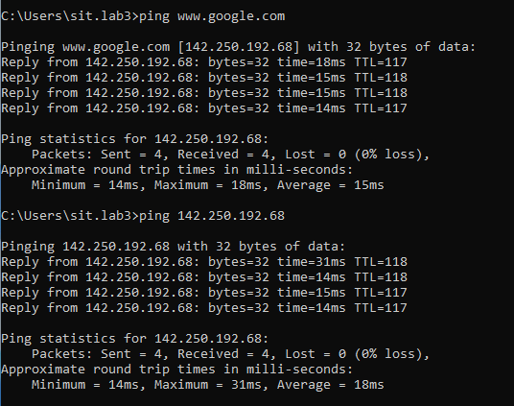

**2.IPCONFIG**

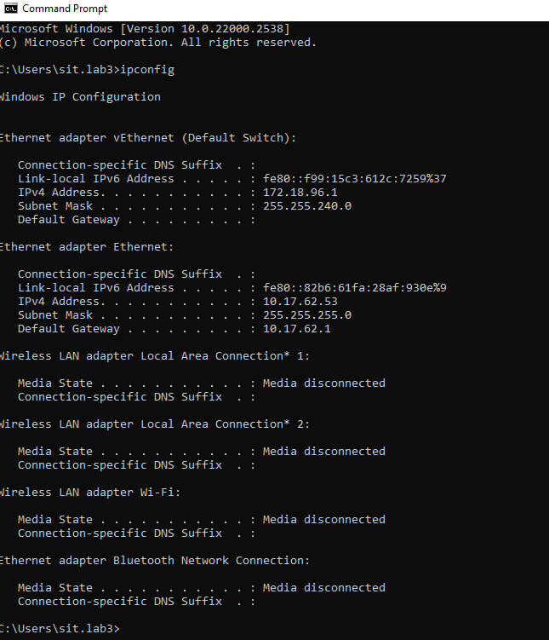

**3.TRACERT**

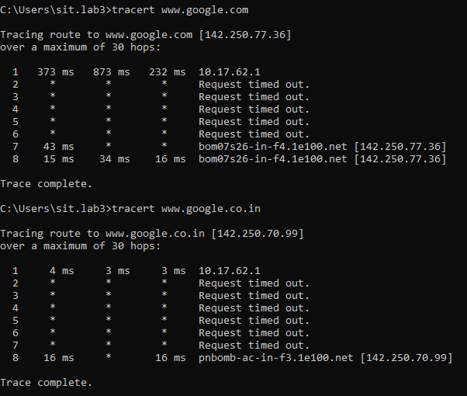

**4.nslookup**

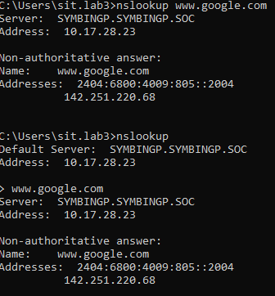

**5.ROUTE PRINT**

